Leetcode question
Reverse Integer - LeetCode
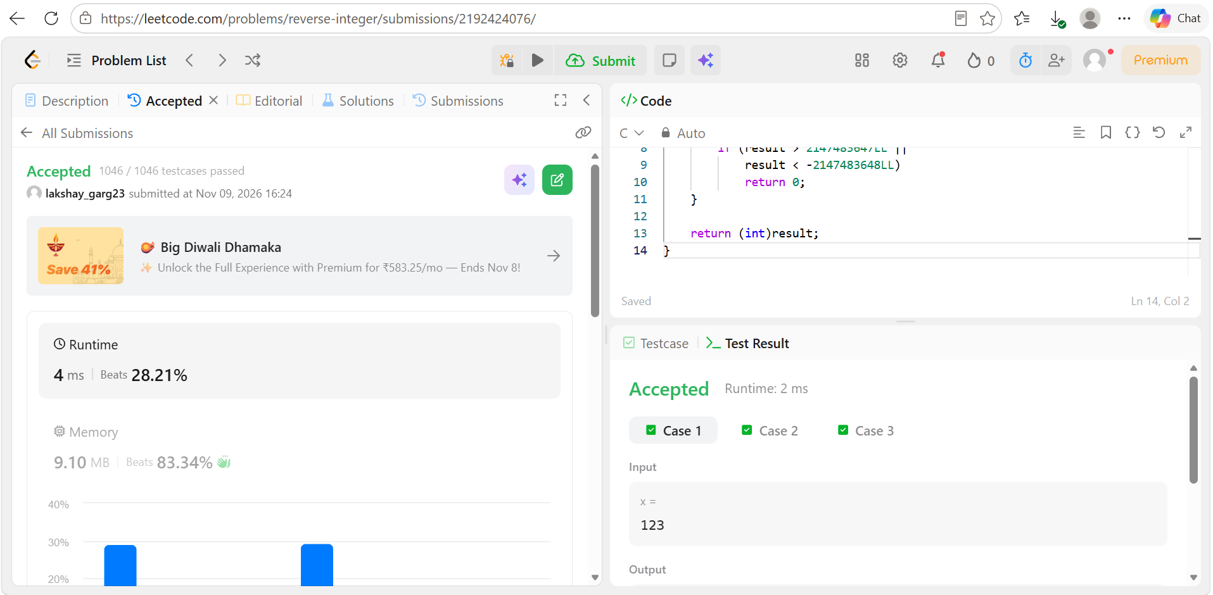
Code
int reverse(int x) {
long long result = 0;

while (x != 0) {
result = result * 10 + x % 10;
x = x / 10;

if (result > 2147483647LL ||
result < -2147483648LL)
return 0;
}

return (int)result;
}

